JOURNAL OF ENGINEERING
AND
APPLIED SCIENCES

Journal of Engineering and Applied Sciences 8(1) (2012), 45-52

Modelling and Simulation of Thermal Decomposition of Acetylated Castor Oil in a Non-Isothermal Reactor
N.A. Amenaghawon, C.O.Okieimen,

Department of Chemical Engineering, Faculty of Engineering, University of Benin, PMB 1154, Benin City, Nigeria
E mail: andrew.amenaghawon@uniben.edu

Abstract
Modelling and simulation are increasingly becoming very important and popular tools in modern day process engineering. This work deals with the modelling and simulation of non-isothermal production of drying oil in a batch reactor which was approximated as a well mixed continuous stirred tank reactor (CSTR). The CSTR model was developed from material and energy balances applied to the reactor. The model is a system of differential and algebraic equations (DAEs) which was simulated at the initial state in order to obtain time invariant values of all variables of interest. Steady state and dynamic analyses were carried out to study the characteristics of the process. Results of dynamic simulation of the CSTR model show that more of the products will be formed if sufficient acetylated castor oil is charged to the reactor and vice versa. The amount of acetylated castor oil initially charged to the reactor had no bearing on the time trajectories of the CSTR’s operating variables. Starting from the base case of adiabatic operation, increasing the supply of external heat input to the reactor leads to a higher conversion and lesser reaction time. The simulation of formulated models as carried out in this work is cheap, safe and less time demanding when compared with real time experiments and provides insight as to how the process under consideration responds to changes in the operating procedure.
Keywords: Acetylated castor oil, drying oil, CSTR, batch reactor, simulation

1. Introduction
Castor oil has long been in existence and has been an article of economic importance since ancient times (Naughton, 1973). Castor oil which is a viscous pale yellow non-volatile oil is unique in that it consists of a large proportion of glycerides of ricinoleic acid.
Table 1: Percentage of fatty acids present in Castor oil (Naughton, 1973)
Fatty acid | Percentage
Ricinoleic acid | 89.5
Linoleic acid | 4.2
Citric acid | 3.0
Stearic acid | 1.0
Palmitic acid | 1.0
Dihydroxystearic acid | 0.7
Eicosanoic acid | 0.3
Linolenic acid | 0.3

The functionality of castor oil lies in its high ricinoleic acid content and the accompanying chemical groups (Mazo et al., 2011). These include: (a) The carboxyl group which provides the capacity for transesterification, hydrolysis, saponification reduction etc.; (b) The unsaturation which provides the capacity for hydrogenation, epoxidation, and addition reactions. (c) The hydroxyl group which provides the capacity for esterification, acetylation or dehydration. These unique properties of castor oil make it a versatile precursor for many industrial chemical products. The presence of the hydroxyl in the oil makes it a suitable candidate for the production of polyurethane elastomers, polyurethane millable, adhesives and coatings and semi-rigid polyurethane foams that have potential uses in thermal insulation. These materials are produced via isocyanate reactions (Quipeng et al., 1990; Yeganeh & Mehdizadeh, 2004; Trevino & Trumbo, 2002; Somani, 2003; Ogunniyi et al., 1996). Also, as a result of the hydroxyl group, the oil can undergo the Diels-Alder reactions of unsaturated fatty acids with maleic anhydride (Mazo et al., 2011). In this case, the oil is dehydrated leading to an increase in its hydrophilicity. The products resulting from these reactions can be utilized as drying oils and water soluble paints.

Drying oil is a kind of vegetable oil which dries under conditions of normal temperature and pressure. Typical examples of drying oils include Linseed oil, Poppy oil, Walnut oil, Sunflower oil and Safflower oil (SundaraRajan, 2011). Other kinds of oils will ordinarily not dry under conditions of normal temperature and pressure. Drying oil is an important component of oil paints. Paints with a high proportion of drying oil will be more transparent and glossy. Drying oil can be produced from acetylated castor oil. The conversion process involves dehydration of the secondary hydroxyl groups of the ricinoleic acid radicals to double bonds at either the 11, 12 or 12, 13 carbon atom positions.

Figure 1: Structural representation of castor oil
A host of successful methods exist for bringing about this dehydration. These methods include: thermal dehydration of ricinoleic acid by distillation and esterification with glycerol, catalytic thermal dehydration of castor oil and thermal decomposition of acetylated castor oil (Grummitt & Fleming, 1945).
A lot of experimental effort (Grummitt & Fleming 1945; Guner, 1997; Howard, 1945; Sanders, 2011) has been put into the production of drying oils. Dynamic modelling of the synthesis process enables the representation of the process in a mathematical sense. Simulation of formulated models can be utilized in analyzing the behaviour of the process under consideration, provision of insights into the mechanisms that drive the process, understanding the response of the process to changes in operating conditions, design of controllers and design of entirely new processes (Suja & Thyagarajan, 2009).
The current work deals with a simulation study of the synthesis of drying oils from thermal cracking of acetylated castor oil in a non-isothermal batch reactor which is a reactor type with non-linear characteristics. The model which is derived from material and energy conservation laws applied to the reactor is a set of differential and algebraic equations (DAEs). Simulation of the formulated model will provide an understanding of the dynamic behaviour of the process and how it responds to changes in operating conditions.
2. Model Development
For the current study, the non-isothermal batch reactor which is modeled as a continuous stirred tank reactor with an outlet vent for acetic acid vapour is shown in Figure 2. The thermal decomposition of acetylated castor oil to produce drying oil proceeds according to the following reaction:
(1)
The acetylated castor oil will be modelled as palmitic acid (C₁₅H₃₁COOH) while the drying oil produced will be modelled as tetradecene (C₁₄H₂₈).
(2)
(3)
Equation (2) represents the thermal cracking of the acetylated castor oil to yield the drying oil and acetic acid (CH₃COOH). This is the primary reaction. Accompanying the primary reaction is a secondary reaction (Equation 3) in which the drying oil dimerizes to form a gum, which will be modelled as C₂₈H₅₆. This is an undesired reaction as it reduces the yield of drying oil.
Q
Vent for acetic acid vapour
Stirrer
Figure 2: Schematic of non-isothermal batch reactor
In formulating the CSTR model, the following assumptions were made:
- The volume of the reactor is fixed
- No nuclear reaction occurs; hence rate of material generation is zero.
- The gas phase is considered ideal and it is described by the ideal gas law.
The content of the reactor is also assumed to be perfectly mixed (lumped system). The implication of this assumption is that all intensive properties of the stream leaving the reactor system are identical to those inside the system.
The CSTR model was obtained from material and energy conservation laws applied to the reactor. The general form of the conservation law for mass is written as:
(4)
For a batch process with no inlet and outlet streams, equation (4) reduces to:
(5)
Equation (5) is applied to all the components within the reactor to obtain the following:

2.1 Material balance:
The equations describing the material balance of all components in the reactor are given as:
(6)
(7)
(8)
(9)
Fractional conversion to acetic acid is given as:
(10)
Fractional conversion of acetylated castor oil is given as:
(11)
The rates of both reactions are described by the following equations:
(12)
(13)
The rate constants are given as (Froment et al. 2011):
(14)
(15)
The units of reaction rate, r_{i}, are mol/m³s, and the activation energy is in J/mol (which is equivalent to kJ/kmol). k₁ and k₂ have units (1/s)
The selectivity of drying oil with respect to the gum is given as:
(16)
2.2 Energy balance:
The equation describing the energy balance of the CSTR obtained from applying the law of conservation of energy to the reactor is given as:
(17)
M^{T} is the total mass of castor charge to the reactor, ΔH_{r} is the heat of reaction J/mol which also accounts for the vaporisation of acetic acid while C_{p} is the specific heat capacity J/kg.K.
The CSTR model is described by the system of equations above which is a set of non-linear differential and algebraic equations (DAEs) and describes the dynamic behaviour of the concentration of all species present in the CSTR and the temperature profile of the reactor content.
3. Model Implementation and Simulation Results
In order to investigate the dynamic behaviour of the batch synthesis of drying oil, the formulated CSTR model which is a system of differential and algebraic equations (DAEs) was implemented in an advanced equation oriented process modelling software gPROMS (2008). gPROMS is an equation oriented general process Modelling System with proven capabilities for the simulation, optimisation and parameter estimation (both steady-state and dynamic) of highly complex processes. It provides an environment for modelling the behaviour of complex systems and allows the user to write equations almost as they would appear on paper. The formulated model was used to investigate the dynamic behaviour of the CSTR. The data utilised for simulation of the model are presented in Table 2.
3.1. Steady state simulation:
Steady state simulation involves solution of the model equations to yield stable values of process variables. Steady state simulation is important in that the values obtained for the process variables at steady state are often used as initial guesses when carrying out dynamic simulations. This is achieved by setting to zero, the time derivatives of the ordinary differential equation (ODE) set that make up the CSTR model. Steady state simulation was carried out at the conditions reported in Table 1 to obtain equilibrium values of the concentration of all species present in the CSTR. Table 3 shows the values of the CSTR’s process variables when the operation is at steady state.
Table 2: Data for dynamic simulation of batch reactor
(Froment et al. 2011; Smith 1970)
Parameter | Value
Heat of reaction | 62800 J/mol
Specific heat capacity | 2510 J/kg.K
Density | 870 kg/m³
Initial conditions:
M_{ACO}
M_{DO}
M_{AA}
M_{gum}
Temperature | 613 K
Reactor volume
Table 3: Steady state values of CSTR variables
Variable | Steady state value
M^{SS}_{ACO} | 0.011 kg
M^{SS}_{DO} | 69.26 kg
M^{SS}_{gum} | 111.73 kg
T | 606.47 K
Q | 0 J/s
3.2. Dynamic simulation
Dynamic process simulation predicts the behaviour of the process in response to step changes in operating conditions. This is usually the next step after carrying out steady state analysis. By using the results obtained from steady state simulation as a starting point, dynamic simulations of the model were run to determine how the process behaved under dynamic conditions. For the base case where the reactor operates adiabatically, Figure 3 shows time trajectories of the mass of acetylated castor oil consumed, mass of drying oil and gum produced respectively as the system reaches steady state. The trend observed indicates that the mass of acetylated castor oil initially charged to the reactor reduces as it is consumed as a result of the stoichiometric formation of drying oil and gum. The mass of drying oil increases up to a maximum value of 155.24 kg after 400 seconds after which it starts reducing.
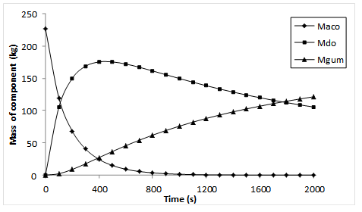
Figure 3: Time trajectories of masses of components in the reactor
Figure 3 shows that the initial rapid increase in the mass of drying oil in the first 400 seconds corresponds to an equally rapid decrease in the mass of acetylated castor oil suggesting that most of the acetylated castor oil was converted to drying oil. However, further decrease in the mass of acetylated castor oil met with a sudden decrease in the mass of drying oil and an observed increasing appearance of gum. This could be attributed to the secondary reaction of dimerization of drying oil to form gum. The increase in the mass of gum is predicted to increase as long as drying oil is present in the reactor. Since it is the desired product, it might be necessary to remove the drying oil from the reactor as soon as it is formed so that it does not dimerize to form gum which is not desired.
3.3. Dynamic simulation for piecewise constant changes in initial ACO charge
A dynamic simulation of the CSTR model was performed to investigate the effect of the initial acetylated castor oil charge to the reactor on the response of the system. This was achieved by introducing piecewise constant step changes in the amount of acetylated castor oil fed to the reactor. The mass of acetylated castor oil fed to the reactor was varied in steps of 25% on both sides of the base value. Two step changes in the amount of acetylated castor oil initially charged to the reactor were investigated. These are -25% of its steady state value and +25% of its steady state value.
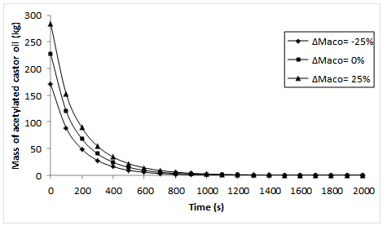
Figure 4: Time response of the mass of acetylated castor oil consumed for various step changes of the initial acetylated castor oil charge
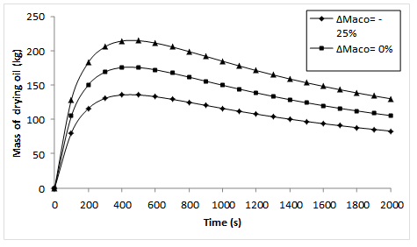
Figure 5: Time response of the mass of drying oil produced for various step changes of the initial acetylated castor oil charge

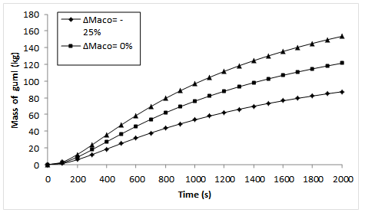
Figure 6: Time response of the mass of gum produced for various step changes of the initial acetylated castor oil charge
Figures 4, 5 and 6 show the response of the amounts of acetylated castor oil, drying oil and gum to 25% increase and 25% decrease in initial acetylated castor oil mass respectively. It was observed that for both step changes considered, the trend initially observed for the mass of acetylated castor oil consumed and the masses of drying oil and gum produced remained the same. This means that the amount of acetylated castor oil initially charged to the reactor has no bearing on the time trajectories of the CSTR’s variables. It can be seen from Figure 4 that essentially all the acetylated castor oil charged to the reactor is consumed if the reaction is given enough time to proceed to completion. Another thing that can be observed from the Figures is that more of the drying oil is produced when more of the acetylated castor oil is available for consumption. This can be seen in the time profile obtained when the initial acetylated castor oil charge was increased by 25% of its base value. Conversely, the lesser the amount of acetylated castor oil in the reactor, the smaller the amount of drying oil produced. This can be seen in the time profile obtained when the initial acetylated castor oil charge was reduced by 25% of the base value. The production of gum followed the same analysis as that of drying oil. As more drying oil was available for the dimerization reaction, more of the gum was formed. The reverse is also true.
3.4. Effect of heat input on the reactor temperature and the conversion of acetylated castor oil
Figures 7 and 8 show the time trajectories of acetylated castor oil conversion and reactor temperature for different heat input rates. These plots show the necessity of adding heat to such a reaction as it is highly endothermic if large conversions are required. From Figure 7, it is seen that for the base case where no heat was supplied to the reactor (adiabatic case), the temperature decreased with time suggesting that if the progression was allowed, it could lead to a cessation of the reaction after a conversion value less than that desired.
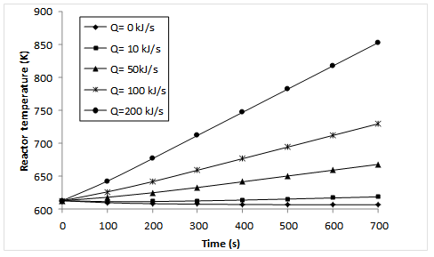
Figure 7: Time trajectories of reactor temperature for different heat input rates
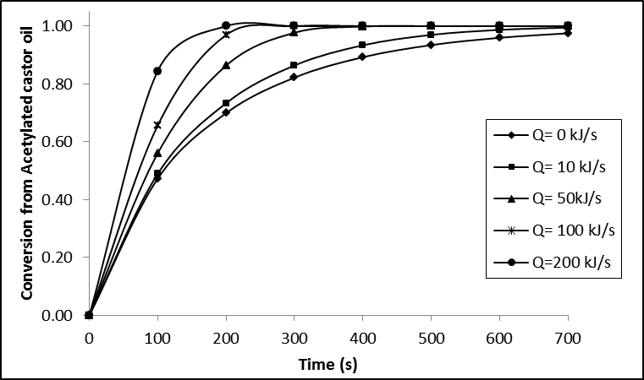
Figure 8: Time trajectories of acetylated castor oil conversion for different heat input rates
Figures 7 and 8 also show the non-adiabatic cases where heat inputs of constant magnitude were supplied to the reactor to determine how the reaction temperature and conversion are affected. The trend observed for both plots indicates that supplying heat to the reactor increases the temperature of reaction progressively and consequently the conversion of acetylated castor oil is increased. It should be noted that the reaction temperature cannot be increased indefinitely by supplying more heat to the reactor even though doing this will make the conversion to approach unity. Reason for this is that the cost of steam necessary to produce such amount of heating is large hence there should be a trade-off between the desired conversion and the amount of heat supplied to the reactor. The choice between high conversion/high cost of steam and low conversion/low cost of steam can be readily made when the conversion takes precedence over every other variable. For this case, the economic benefits of obtaining a high conversion will more than offset the cost of steam required to bring it about.
Another result that can be obtained from Figure 8 is the time required to achieve a given conversion. The case considered here is the time required to achieve a conversion of 80% as shown by the horizontal line in Figure 8. The conversion value of 80% was arbitrarily and hypothetically chosen to represent most real life process scenarios. It can be observed that different simulated reaction times are required to obtain a conversion of 80% for different heat input rates. Table 4 shows the reaction times required for 80% conversion for different heat inputs. The results presented in Table 4 also show the importance of supplying heat to the reactor. The trend observed indicates that as the amount of heat supplied to the reactor is increased, the time required to achieve 80% conversion of acetylated castor oil reduces.
Table 4: Reaction times required for 80% conversion for different heat inputs
Heat input rate (kJ/s) | Reaction time (s)
Q=0 (adiabatic) | 278
10 | 243
50 | 172
100 | 131
200 | 93

In terms of process economics, the requirement will be to have a reaction time that is as small as possible. This can be achieved in principle by increasing the amount of heat supplied to the reactor. But then as mentioned earlier, heat supplied to the reactor cannot be sustained indefinitely, so a trade-off has to exist between the desired reaction time and the amount of heat supplied to the reactor.
4. Conclusions
In this work, the modelling and simulation of a non-isothermal CSTR for drying oil synthesis from acetylated castor oil was studied. This is a typical nonlinear system with lumped parameters. The CSTR model was developed from material and energy conservation laws as applied to the reactor. The resulting model is a nonlinear system of differential and algebraic equations (DAEs).
For steady state analysis, the CSTR model was simulated at the initial state to obtain stable values of all CSTR variables of interest. Using the steady state as a starting point, dynamic simulation of the CSTR model resulted in the time trajectories of all CSTR variables of interest. Results of dynamic analysis show that piecewise constant increase in the initial acetylated castor oil charge to the reactor leads to the formation of more drying oil and consequently more gum. Also, piecewise constant decrease in the initial acetylated castor oil charge to the reactor leads to the formation of less drying oil and consequently less gum. The comparison in this case is with the base case of 227kg of acetylated castor oil. The amount of acetylated castor oil initially charged to the reactor has no bearing on the time trajectories of the CSTR’s variables. Increasing the supply of external heat input to the reactor leads to a higher conversion and lesser reaction time. This follows from the fact that the reaction that produces drying oil from acetylated castor oil is endothermic, hence it is necessary to increase the heat input in order to obtain the desired conversion of acetylated castor oil to drying oil.
Nomenclature
Mass
M_{AA} Mass of acetic acid formed (kg)
M_{ACO} Mass of acetylated castor oil consumed (kg)
M_{DO} Mass of drying oil formed (kg)
M_{gum} Mass of gum formed (kg)
M^{O}_{AA} Initial mass of acetic acid in reactor (kg)
M^{O}_{ACO} Initial mass of acetylated castor oil charged to
reactor (kg)
M^{O}_{DO} Initial mass of drying oil in reactor (kg)
M^{SS}_{ACO} Steady state value of mass of acetylated castor
oil consumed (kg)
M^{SS}_{DO} Steady state value of mass of drying oil
produced (kg)
M^{SS}_{gum} Steady state value of mass of gum produced
(kg)
Rates
k₁ Rate constant for reaction 1 (1/s)
k₂ Rate constant for reaction 2 (1/s)
r₁ Rate of reaction 1 (mol/m³s)
r₂ Rate of reaction 2 (mol/m³s)
Others
C_{p} Specific heat capacity of reactor content
(J/kg.K)
ρ Density of reactor content (kg/m³)
ΔH_{r} Heat of reaction (J/s)
Q Rate of external heat input to reactor (J/s)
R Universal gas constant (J/mol.K)
T Reactor temperature (K)
X_{AA} Conversion to acetic acid
X_{ACO} Conversion from acetylated castor oil
Reference
Froment, G.F., Bischoff, K.B. & De Wilde, J., 2011. Chemical reactor analysis and design 3rd ed., New York: John Wiley & Sons, Inc.
gPROMS (2008). Introductory User Guide, Process System Enterprise Ltd (PSE).
Grummitt, O. & Fleming, H., 1945. Acetylated Castor Oil. Industrial & Engineering Chemistry, 37(5), 485–491.
Guner, F.S., 1997. Castor oil dehydration kinetics. Journal of the American Oil Chemists’ Society, 74(4), 409–412.
Howard, M., 1945. Drying oils. Oil & Soap, 22(10), 275–276.Mazo, P.C., Estenoz, D. & Rios, L.A., 2011. Kinetics of the esterification of maleic anhydride with castor oil. Latin American Applied Research, 41(1).
Naughton, F., 1973. Production, Chemistry, and Commercial Applications of Various Chemicals from Castor Oil. Journal of the American Oil Chemists’ Society, 51(3), 65–71.
Ogunniyi, D.S., Ola, A. & Fakayejo, W.R.O., 1996. Preparation and Properties of Polyurethane Foams from Toluene Diisocyanate and Mixtures. Iranian Polymer Journal (English Edition), (19)6, 56–59.
Quipeng, G., Shixia, F. & Qingyu, Q., 1990. Polyurethanes from 2,4-toluene diisocyanate and a mixture of castor oil and hydroxyether of bisphenol. European Polymer Journal, 26(11), 1177–1180.
Sanders., 2011. Drying Oils and Mediums. Available at: http://www.sanders-studios.com/instruction/tutorials/historyanddefinitions/dryingoils.html [Accessed September 1, 2011].
Smith, J.M., 1970. Chemical Engineering Kinetics 2nd ed., McGraw-Hill Inc.
Somani, K., 2003. Castor oil based polyurethane adhesives for wood-to-wood bonding. International Journal of Adhesion and Adhesives, 23(4), 269–275.
Suja, M.R,M & Thyagarajan, T., 2009. Modelling of continuous stirred tank reactor using artificial intelligence techniques. International Journal of Simulation and Modelling, 8(3), 145–155.
SundaraRajan, M., Drying Oil Production: Primary Information Services. Available at: http://www.primaryinfo.com/projects/drying-oil.htm [Accessed September 1, 2011].
Trevino, A.. & Trumbo, D., 2002. Acetoacetylated castor oil in coatings applications. Progress in Organic Coatings, 44(1), 49–54.
Yeganeh, H. & Mehdizadeh, M.., 2004. Synthesis and properties of isocyanate curable millable polyurethane elastomers based on castor oil as a renewable resource polyol. European Polymer Journal, 40(6), 1233–1238.

